GRAIL FULL PACKAGE

FRONT LABEL
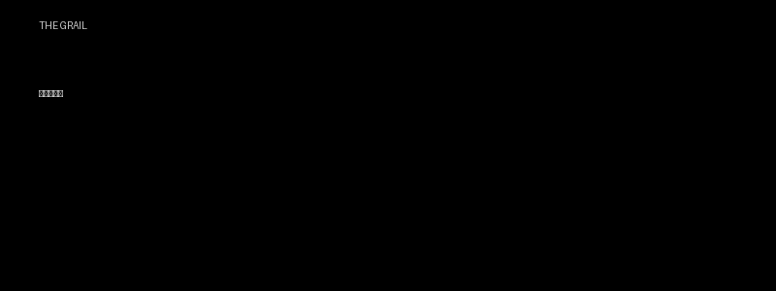

BACK LABEL
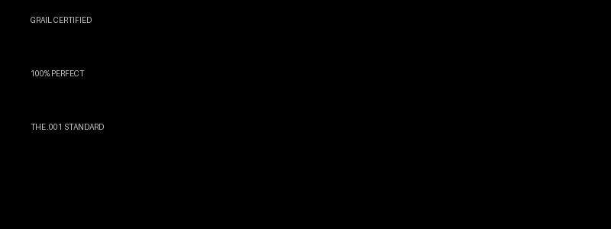

SECTION MOCK
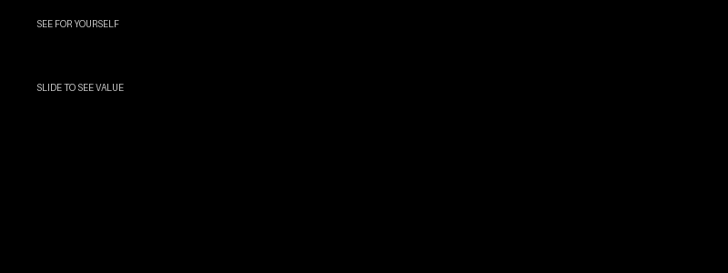

INSTRUCTIONS
Use images EXACTLY. Do not redesign. Apply logic as previously defined.

